CAUTION
ADMITTANCE TO AUTHORIZED PERSONNEL ONLY ONLY

NO EATING, DRINKING,
OR SMOKING PERMITTED IN THE LAB

PUBLIC SAFETY (24 HOURS) X4545 EH&S’s Laboratory Safety Unit X4477
FIRE/MEDICAL EMERGENCY 911 EH&S’s Radiation Safety Unit X4477

Directions: Place an X in the box left of the Pictogram if the hazard is present in your lab. If large quantities are present, check the box to the right of the pictogram.
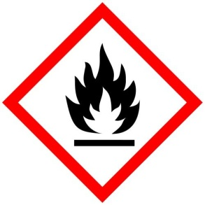 Large Quantities  Flammables Over 10 gallons | 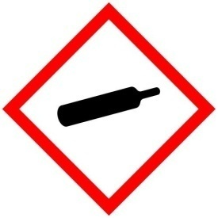 Large Quantities  Compressed Gases Over 400 Liters | 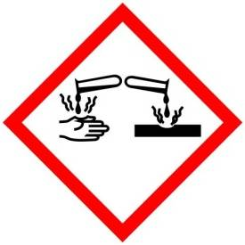 Large Quantities  X  Corrosive Over 10 gallons | 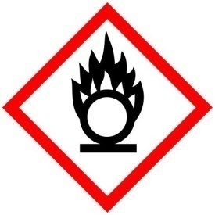 Large Quantities  Oxidizer Over 10 gallons
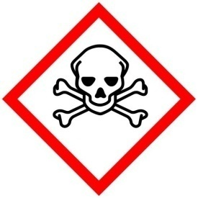  Acute Toxicity Large Quantities  Over 500 grams | 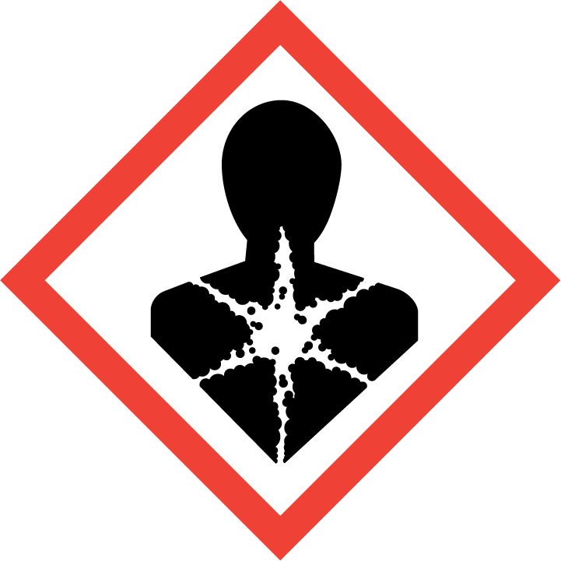  Carcinogen Large Quantities  Reproductive Hazard Over 500 grams | 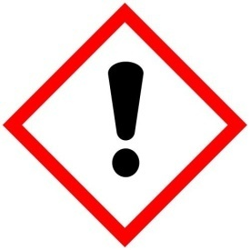  Irritant Large Quantities  Sensitizer Over 5 Kilograms | 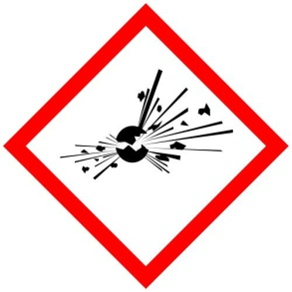  Explosive Large Quantities  Over 1 Kilograms
Visitors and Facilities: Consult Laboratory Staff for necessary Personal Protective Equipment.

CONTACT | NAME | DEPARTMENT/OFFICE ROOM | PHONE
Lab Principal Investigator
TAMUG Safety Officer
Courtesy: University of Rochester; https://www.safety.rochester.edu/labsafety/signage/labdoorsignage.html
DATE POSTED: Update sign when major changes occur.

